Introduction: The goal of this section is to turn our previous diagram into a more concrete definition so that we can create a database for a library. The system will be able to manage users, the checking out of books, manage inventory, apply late fees, and more.

Relational Schema Mapping:

* Book Borrowing
  + Client Id, item id, borrowed date, due date, return date
* Magazine Borrowing
  + Client id, item id, borrowed date, due date, return date
* Digital Media Borrowing
  + Client id, item id, borrowed date, due date, return date

Determine Primary Keys:

* Book
  + ISBN
* Book Copy
  + copy_ID
* Book borrowing:
  + Client id, item id, borrow date
* Magazine borrowing:
  + Client id, item id, borrow date
* Digital Media borrowing:
  + Client id, item id, borrow date
* Magazine
  + Magazine ID
* Digital Media
  + digital_media_id
* Membership type
  + membership_type
* Client
  + Unique_id
* Fee
  + Fee_id, client_id

Establish Foreign Keys:

* Book:
  + No foreign keys
* Book Copy:
  + ISBN
* Book borrowing:
  + Client id, item id
* Magazine borrowing:
  + Client id, item id
* Digital Media borrowing:
  + Client id, item id
* Magazine:
  + No foreign keys
* Digital Media:
  + No foreign keys
* Membership type:
  + No foreign keys
* Client:
  + membership_type
* Fee:
  + Client_id

Schema Documentation:

* Relational Schema Diagram
* 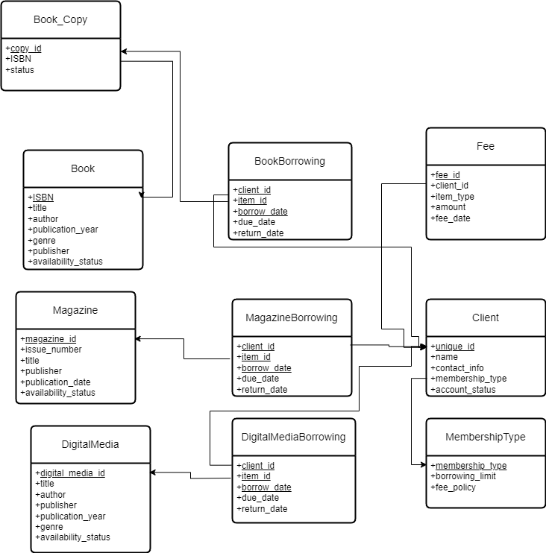
* Data Dictionary

| Book | | | |
| --- | --- | --- | --- |
| Attribute Name | Data Type | Domain | Constraints |
| ISBN | VARCHAR | Valid ISBN Format | Primary Key |
| title | VARCHAR | String up to 255 characters | Not Null |
| author | VARCHAR | String up to 255 characters | Not Null |
| publication_year | INT | Positive Integer | CHECK (publication_year>0) |
| genre | VARCHAR | String up to 100 characters |  |
| publisher | VARCHAR | String up to 255 characters |  |

| Book_Copy | | | |
| --- | --- | --- | --- |
| Attribute Name | Data Type | Domain | Constraints |
| copy_id | SERIAL | Sequential integer starting from 1 | Primary Key |
| ISBN | VARCHAR | Valid ISBN Format, String references Book.ISBN | Foreign Key, Not Null |
| status | VARCHAR | String from list of values | DEFAULT ’Available’, CHECK(status IN ('Available', 'Borrowed', 'Reserved', 'Lost', 'Maintenance')) |

| DigitalMedia | | | |
| --- | --- | --- | --- |
| Attribute Name | Data Type | Domain | Constraints |
| digital_media_id | SERIAL | Sequential integer starting from 1 | Primary Key |
| title | VARCHAR | String up to 255 characters | Not Null |
| author | VARCHAR | String up to 255 characters | Not Null |
| publisher | VARCHAR | String up to 255 characters | Not Null |
| publication_year | INT | Positive Integer | CHECK (publication_year>0) |
| availability_status | VARCHAR | String from list of values | DEFAULT ‘Available’, CHECK (availability_status IN ('Available', 'Borrowed', 'Reserved')) |
| genre | VARCHAR | String up to 100 characters |  |

| Magazine | | | |
| --- | --- | --- | --- |
| Attribute Name | Data Type | Domain | Constraints |
| magazine_id | SERIAL | Sequential integer starting from 1 | Primary Key |
| issue_number | INT | Positive Integer | Not Null |
| title | VARCHAR | String up to 255 characters | Not Null |
| publisher | VARCHAR | String up to 255 characters | Not Null |
| publication_date | DATE | Date in the “YYYY-MM-DD” Format |  |
| availability_status | VARCHAR | String from list of values | DEFAULT ‘Available’, CHECK (availability_status IN ('Available', 'Borrowed', 'Reserved')) |

| MembershipType | | | |
| --- | --- | --- | --- |
| Attribute Name | Data Type | Domain | Constraints |
| membership_type | VARCHAR | String up to 100 characters | Primary Key |
| borrowing_limit | INT | Positive Integer | Not Null |
| fee_structure | VARCHAR | String up to 255 characters |  |

| Client | | | |
| --- | --- | --- | --- |
| Attribute Name | Data Type | Domain | Constraints |
| unique_id | SERIAL | Sequential integer starting from 1 | Primary Key |
| name | VARCHAR | String up to 255 characters | Not Null |
| contact_info | VARCHAR | String up to 255 characters |  |
| membership_type | VARCHAR | String that references MembershipType.membership_type | Foreign Key, Not Null |
| account_status | VARCHAR | String from list of values | Not Null, CHECK (account_status IN ('Active', 'Suspended', 'Expired')) |

| BookBorrowing | | | |
| --- | --- | --- | --- |
| Attribute Name | Data Type | Domain | Constraints |
| client_id | INT | integer referencing Client.unique_id | Primary Key, Foreign Key, Not Null |
| item_id | INT | integer referencing Book_Copy.copy_id | Primary Key, Foreign Key, Not Null |
| borrow_date | DATE | Date in the "YYYY-MM-DD" Format | Primary Key, Not Null |
| due_date | DATE | Date in the "YYYY-MM-DD" Format | Not Null |
| return_date | DATE | Date in the "YYYY-MM-DD" Format |  |

| DigitalMediaBorrowing | | | |
| --- | --- | --- | --- |
| Attribute Name | Data Type | Domain | Constraints |
| client_id | INT | integer referencing Client.unique_id | Primary Key, Foreign Key, Not Null |
| item_id | INT | integer referencing DigitalMedia.digital_media_id | Primary Key, Foreign Key, Not Null |
| borrow_date | DATE | Date in the "YYYY-MM-DD" Format | Primary Key, Not Null |
| due_date | DATE | Date in the "YYYY-MM-DD" Format | Not Null |
| returrn_date | DATE | Date in the "YYYY-MM-DD" Format |  |

| MagazineBorrowing | | | |
| --- | --- | --- | --- |
| Attribute Name | Data Type | Domain | Constraints |
| client_id | INT | integer referencing Client.unique_id | Primary Key, Foreign Key, Not Null |
| item_id | INT | integer referencing Magazine.magazine_id | Primary Key, Foreign Key, Not Null |
| borrow_date | DATE | Date in the "YYYY-MM-DD" Format | Primary Key, Not Null |
| due_date | DATE | Date in the "YYYY-MM-DD" Format | Not Null |
| returrn_date | DATE | Date in the "YYYY-MM-DD" Format |  |

| Fee | | | |
| --- | --- | --- | --- |
| Attribute Name | Data Type | Domain | Constraints |
| fee_id | SERIAL | Sequential integer starting from 1 | Primary Key |
| client_id | INT | integer referencing Client.unique_id | Foreign Key, Not Null |
| item_type | VARCHAR | String up to 50 characters | Not Null |
| amount | DECIMAL | Positive decimal number | Not Null |
| fee_date | DATE | Date in the "YYYY-MM-DD" Format | Not Null |

Generate DDL:

CREATE TABLE Book (

ISBN VARCHAR(20) PRIMARY KEY,

title VARCHAR(255) NOT NULL,

author VARCHAR(255) NOT NULL,

publication_year INT CHECK (publication_year > 0),

genre VARCHAR(100),

publisher VARCHAR(255)

);

CREATE TABLE Book_Copy (

copy_id SERIAL PRIMARY KEY,

ISBN VARCHAR(20) NOT NULL,

status VARCHAR(20) DEFAULT 'Available' CHECK (status IN ('Available', 'Borrowed', 'Reserved', 'Lost', 'Maintenance')),

FOREIGN KEY (ISBN) REFERENCES Book(ISBN)

);

CREATE TABLE DigitalMedia (

digital_media_id SERIAL PRIMARY KEY,

title VARCHAR(255) NOT NULL,

author VARCHAR(255) NOT NULL,

publisher VARCHAR(255) NOT NULL,

publication_year INT CHECK (publication_year > 0),

genre VARCHAR(100),

availability_status VARCHAR(20) DEFAULT 'Available' CHECK (availability_status IN ('Available', 'Borrowed', 'Reserved'))

);

CREATE TABLE Magazine (

magazine_id SERIAL PRIMARY KEY,

issue_number INT NOT NULL,

title VARCHAR(255) NOT NULL,

publisher VARCHAR(255) NOT NULL,

publication_date DATE,

availability_status VARCHAR(20) DEFAULT 'Available' CHECK (availability_status IN ('Available', 'Borrowed', 'Reserved'))

);

CREATE TABLE MembershipType (

membership_type VARCHAR(100) PRIMARY KEY,

borrowing_limit INT NOT NULL,

fee_structure VARCHAR(255)

);

CREATE TABLE Client (

unique_id SERIAL PRIMARY KEY,

name VARCHAR(255) NOT NULL,

contact_info VARCHAR(255),

membership_type VARCHAR(100) NOT NULL,

account_status VARCHAR(20) NOT NULL CHECK (account_status IN ('Active', 'Suspended', 'Expired')),

FOREIGN KEY (membership_type) REFERENCES MembershipType(membership_type)

);

CREATE TABLE BookBorrowing (

client_id INT NOT NULL,

item_id INT NOT NULL, -- copy_id from Book_Copy

borrow_date DATE NOT NULL,

due_date DATE NOT NULL,

return_date DATE,

PRIMARY KEY (client_id, item_id, borrow_date),

FOREIGN KEY (client_id) REFERENCES Client(unique_id),

FOREIGN KEY (item_id) REFERENCES Book_Copy(copy_id)

);

CREATE TABLE DigitalMediaBorrowing (

client_id INT NOT NULL,

item_id INT NOT NULL, -- digital_media_id

borrow_date DATE NOT NULL,

due_date DATE NOT NULL,

return_date DATE,

PRIMARY KEY (client_id, item_id, borrow_date),

FOREIGN KEY (client_id) REFERENCES Client(unique_id),

FOREIGN KEY (item_id) REFERENCES DigitalMedia(digital_media_id)

);

CREATE TABLE MagazineBorrowing (

client_id INT NOT NULL,

item_id INT NOT NULL, -- magazine_id

borrow_date DATE NOT NULL,

due_date DATE NOT NULL,

return_date DATE,

PRIMARY KEY (client_id, item_id, borrow_date),

FOREIGN KEY (client_id) REFERENCES Client(unique_id),

FOREIGN KEY (item_id) REFERENCES Magazine(magazine_id)

);

CREATE TABLE Fee (

fee_id SERIAL PRIMARY KEY,

client_id INT NOT NULL,

item_type VARCHAR(50) NOT NULL,

amount DECIMAL(10, 2) NOT NULL,

fee_date DATE NOT NULL,

FOREIGN KEY (client_id) REFERENCES Client(unique_id)

);

Normalization Considerations: While normalization is not required right now, we must consider normalization since there is a bit of redundancy with tables having repeated publisher and author categories and the borrowing tables having some repeated values, creating unique queries could cause an overlap with these categories.

Appendices:

* There is currently no addition needed here, but it will be updated as required.

Github Repository Management:

* A new path was added for the Logical Relational Schema Design to easily separate this document from previous documents
* The file was also uploaded into the documents of the repository.

t: